IDENTIFYING TREATED TIMBER

You can’t tell the timber’s treatment level by the method used to treat it or how it looks. Only its H level tells you this. Colour is not a good indicator as it can vary along a stick and the way the colour pigment settles has nothing to do with whether or not the treatment has penetrated the timber.

The easiest way to identify treated timber is to look at its treatment brand. This can be:

* A tag stuck onto the timber
* An ink-stamp printed directly onto the stick of timber during manufacture
* Burned onto the end of the timber
* A label on the timber pack (pack label). This is used for smaller pieces of timber where it isn’t practical to attach a tag to each piece e.g. palings.

The treatment brand includes:

1. Where the timber was treated (manufacturer code).
2. Which preservative was used (chemical code).
3. The H level it has been treated to.

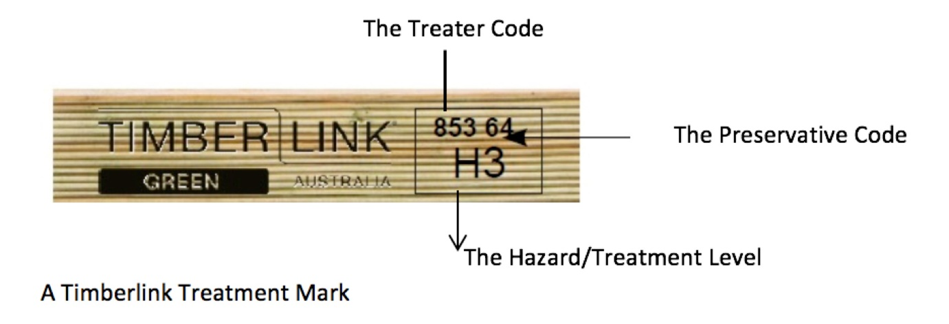

Additionally if the timber has been treated with CCA, it is compulsory to have the words “TREATED WITH COPPER CHROME ARSENATE” clearly marked on the timber.

Preservatives and their chemical codes used by Timberlink are:

* Code 60 = Imidacloprid Timberlink Blue H2F
* Code 74 = Permethrin Timberlink Blue H2F
* Code 58 = Tanalith E H3 & H4
* Code 64 = LOSP Timberlink Green H3
* Code 01 = CCA (Copper Chrome Arsenate) H4 and H5

Examples of Treatment tags/stamps

